**AddEmployeeWindow.xaml.cs**

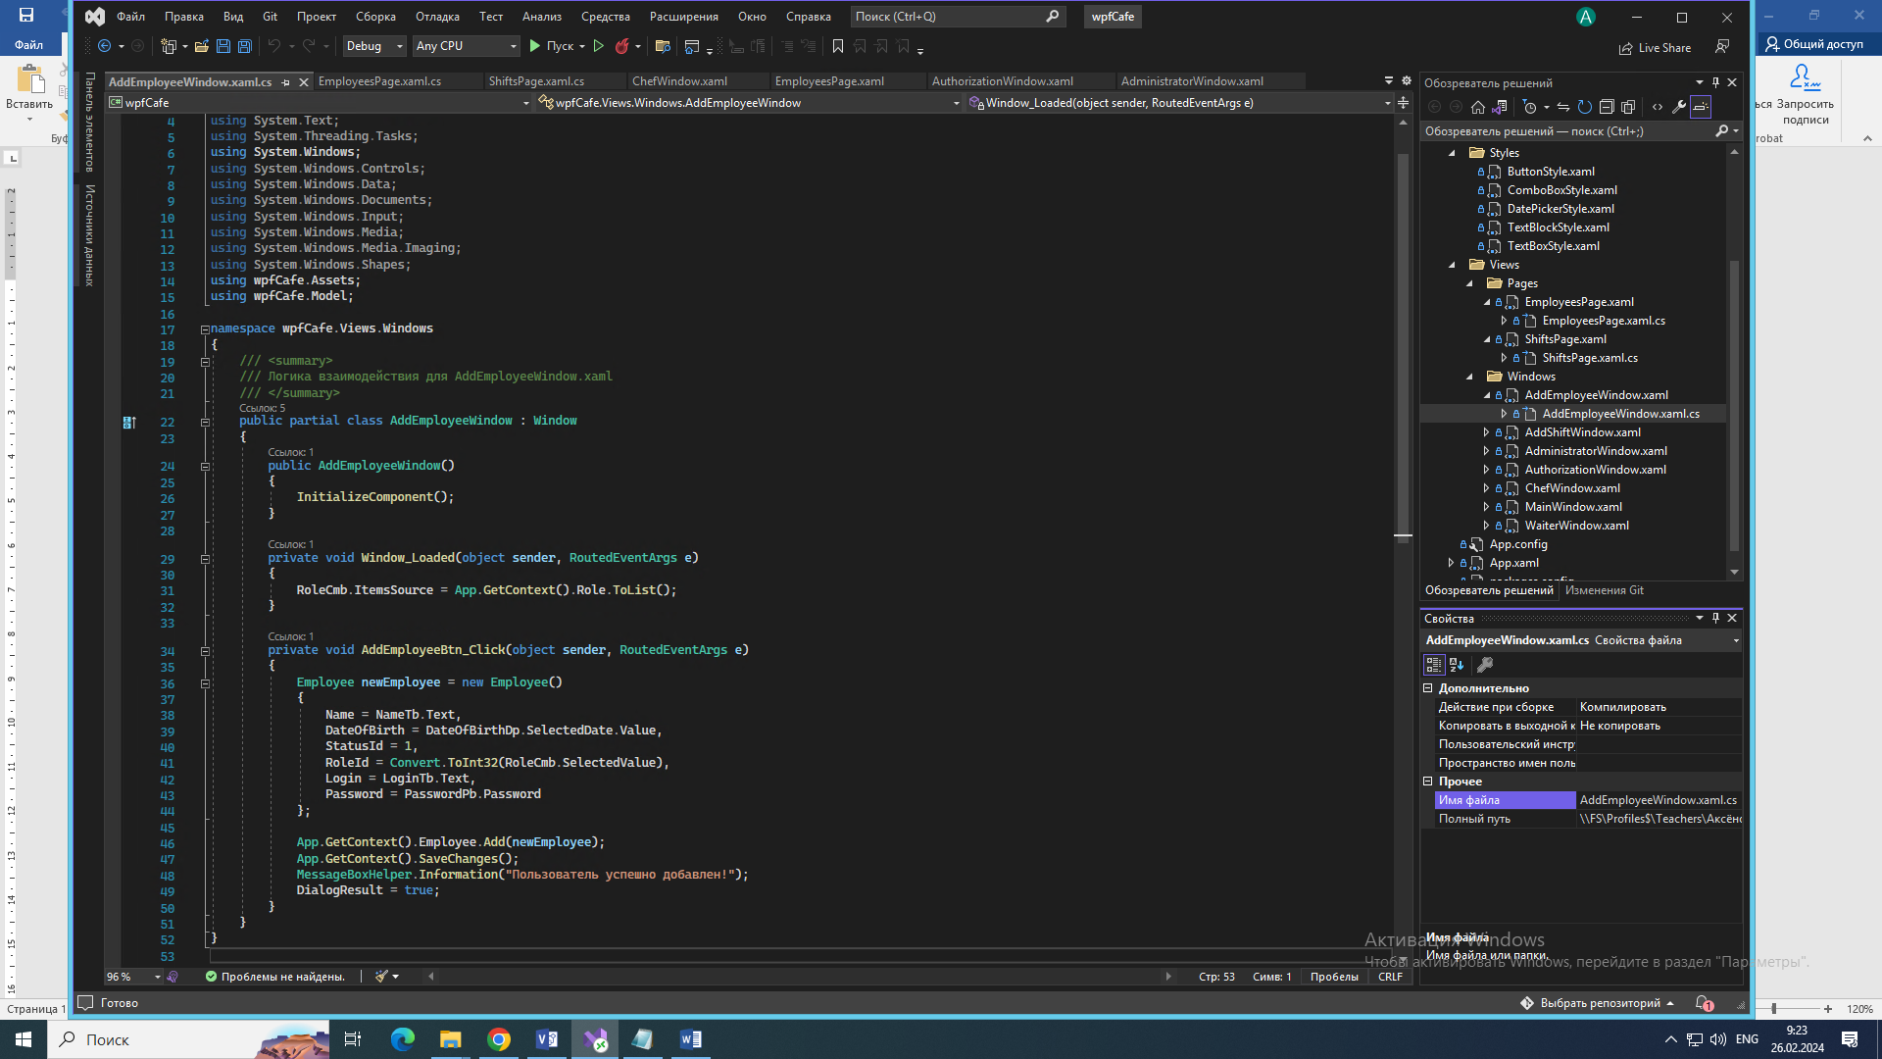

**AddShiftWindow.xaml.cs**

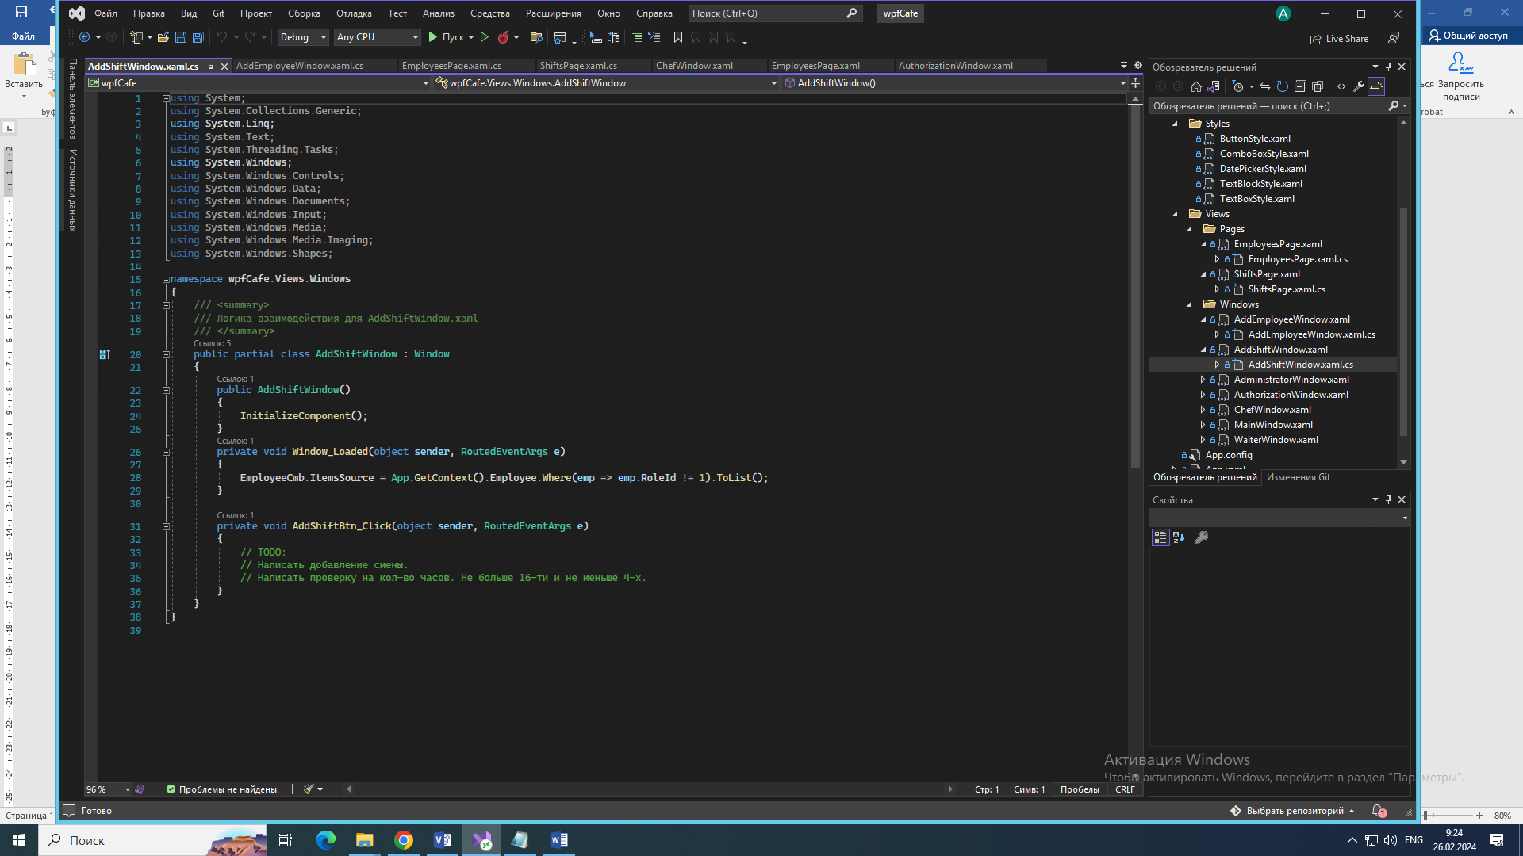

**AdministratorWindow.xaml.cs**

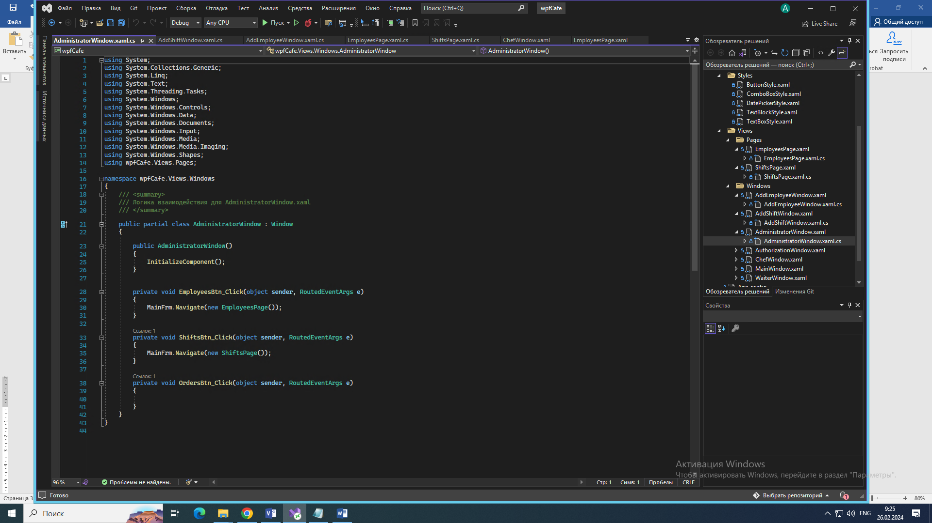

**AuthorizationWindow.xaml.cs**

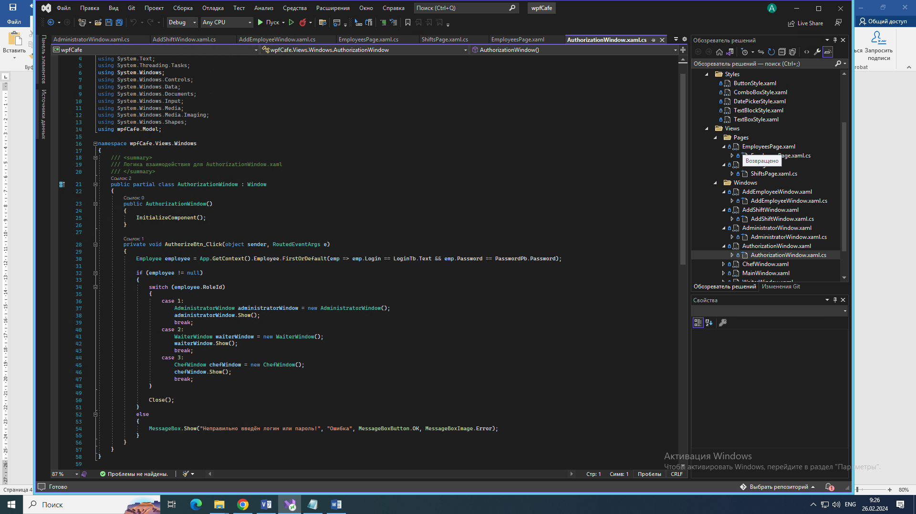

**Assets =>**

**MessageBoxHelper.cs**

